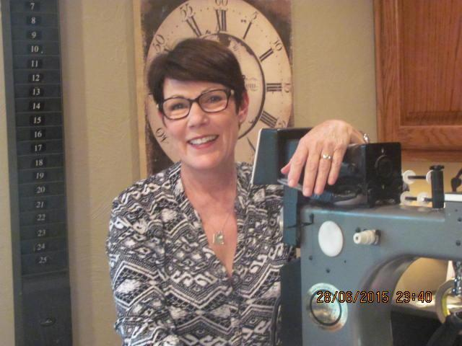
Sandy Gard
Sandy is a self-taught seamstress and quilter. At the age of six, she was cutting and sewing clothes for her dolls by hand. At the age of eight, she had her first experience at hand quilting. At her grandmother’s farmhouse in Sulphur Springs, TX all the neighbors gathered and they lowered the quilting frame from the living room ceiling. They all sat around the quilt, hand quilting and chatting from there her love of quilting began. It has been a lifelong love affair.
Sandy has had a home-based sewing business for 21 years. In 2007, Sandy purchased a Gammill long-arm quilting machine. Her wonderful husband had a room addition added to their home and she has been successfully quilting for customers since then. Sandy has quilted over 800 customer quilts.
In 2014, Sandy entered the National Quilt Association Judging program. She has spent four years working with certified judges and judging quilt shows. She received her certification in 2019. She has judged in Arkansas, Texas, Arizona, Nebraska, Alabama, and Oklahoma. She holds positions on four quilt guild boards and is the judging coordinator for two.
Her personal statement: Quilting is a time-honored tradition. I love the history and future of quilting and I love promoting the tradition to new quilters of any age.

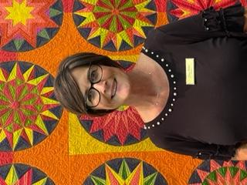

Stacy Miller

Stacy lives in Paris, TX and has a bachelor’s degree of science in nursing from the University of Texas at Arlington, and has worked as a registered nurse for over 30 years. Her love of sewing came later in life but she remembers her mother sewing and watching intently for hours, amazed at how the sewing machine and her mother worked magic! She says her sewing started after her nursing career and it hasn’t slowed yet!

Stacy is a member of the American Quilters society and is currently a candidate in the National Association of Certified Quilt Judges. She is also active in her local quilt guild, Red River Valley Quilt Guild where she was one of the co-founders of their Eiffel In Love with Quilting Quilt Show which started in 2019, and is head of the intake of quilts and the display coordinator.

Stacy has shown her quilts in local small shows where her first quilt (a rag caterpillar) took Grand Champion. She looks forward to showing in more shows in the future.

Stacy has 2 children and 2 granddaughters.

Stacy’s Judging philosophy: Everyone’s quilt has a special meaning to them, I strive to see their love for their quilt, giving them encouraging words so that they will want to continue to sew and to pass that love to their friends and family for many generations to come. Using the principles of design and workmanship skills for each piece with equal accountability.

